Loan Payoff

[BANNO.LOAN.PAYOFF.V1.POW]

Program Overview

Table of Contents

Overview 1

UX Run-Time Detail 1

PowerOn Run-Time Detail 1

Program setup & Installation 2

Required Files 2

Installation steps 2

Configuration Letter file 2

Database Interaction 3

Data Sources 3

Additional Information 3

Loan Tracking Records 3

Program Change History 4

BANNO.LOAN.PAYOFF.V1.POW

# Overview

This PowerOn allows the user to request a loan payoff amount including interest and late fees for a selected date.

Loan payoffs are only available on in-house loans. The payoff option will not display for any 3rd party loans. Credit Card loans will not display the interest rate as they typically have different interest rates for different portions of the balance.

# UX Run-Time Detail

Upon the member electing to run the program, the Banno UX displays the loan selected and Payoff Date. The Payoff Date defaults to today, but the member may click the link to select a future payoff date from a calendar. Customizable Terms and Conditions verbiage will also display to the member.

Upon selecting Calculate, a Loan Payoff screen is displayed for the member to view the calculated payoff amount and details.

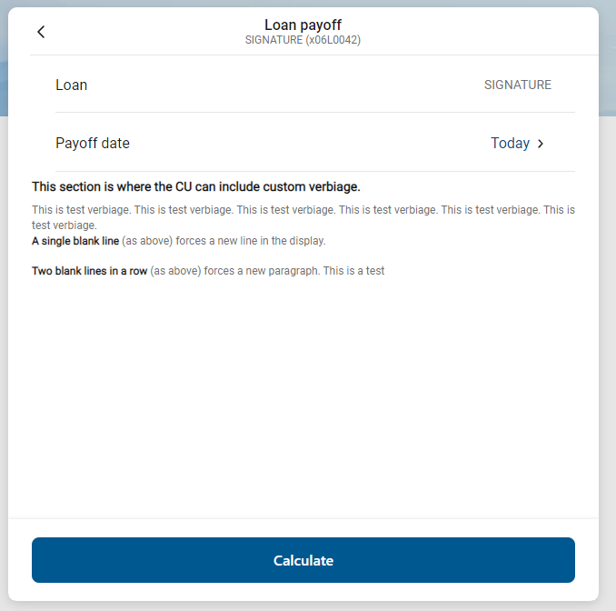 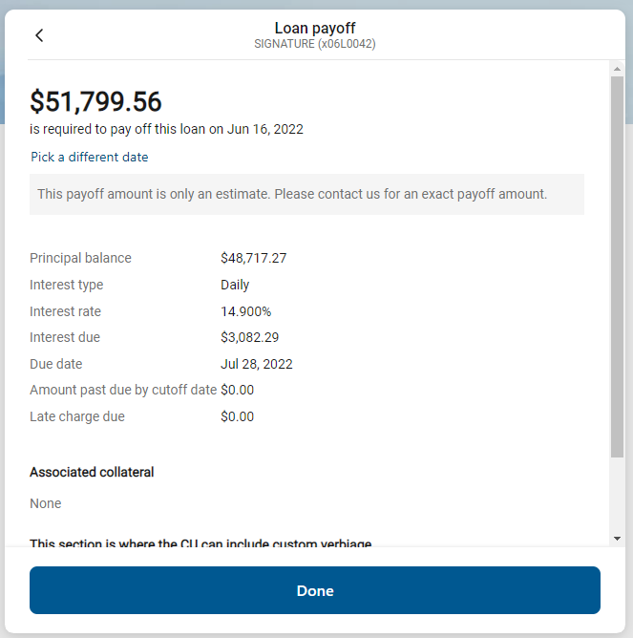

# PowerOn Run-Time Detail

When first run by the member, Banno passes back to the PowerOn the account and loan ID the member is requesting payoff for. The program takes this info, reads the various parameter settings from the configuration Letter file and determines account eligibility. The PowerOn will pass back to the UX if the loan is eligible, the number of days in the future a payoff can be requested, and the terms and conditions. If eligible, once the member selects the desired payoff date, that date is passed back to the PowerOn from the Banno UX and the PowerOn then calculates the loan payoff amount. It then passes this information to the Banno UX to be presented to the member.

# Program setup & Installation

Upload the necessary files to their respective folders. The easiest way to upload them is to use the Episys PC Transfer function.

## Required Files

* + REPWRITERSPECS folder
* BANNO.LOAN.PAYOFF.V1.POW (Main PowerOn program)
* Standard PowerOn Library include files which should already be in your system:
  + RD.GETDATA.DEF
  + RB.LISTEXAND.DEF
  + RB.LISTEXPAND
  + LETTERSPECS folder
* BANNO.LOAN.PAYOFF.V1.CFG (Main program configuration Letter file)

## Installation steps

* Upload files to their respective directories
* Install the PowerOn program for demand use
* Add the PowerOn program name to SymXchange Common Parameters
* Refresh SymXchange
* Update the settings in the configuration Letter file. The configuration Letter file contains details for the various settings
* Add the program to Banno People

## Configuration Letter file

The configuration Letter file allows certain aspects of the program to be customized to better suit your needs. Among the options which can be set are:

* Determine member eligibility by account warning code(s)
* Determine loan eligibility by loan type(s), loan warning code(s)
* Determine the number of days in the future for which a loan payoff can be requested
* Determine home loan, boat loan, vehicle loan, and secured loan types to identify collateral for display
* Set Terms and Conditions to be displayed to the member regarding the payoff

The configuration Letter file contains full instructions on setting these run-time parameters. Do pay close attention when selecting your options making sure to set each option within the required parameters.

# Database Interaction

## Data Sources

Data utilized by the program is pulled from the following sources:

* Member’s open internal loan records
* Loan Tracking records
* Loan Name records
* Loan Pledge records

# Additional Information

### Loan Tracking Records

The program uses these tracking records to store boat and vehicle collateral information. The CU can specify in the configuration Letter file which field(s) contain collateral information.

# Program Change History

Ver.1.0.0 01/27/20: C. Simms

* + Original Programming

Ver.1.0.1 06/10/20: T. Kainz- Banno

* + Corrected issue with vehicle and boat collateral display

Ver.1.0.2 05/13/21: T. Kainz- Banno

* + Addressed JSON issue when collateral in targeted tracking was not filled in.
  + Enhanced CFG file validation.
  + Added program Info & CFG LF JSON output.
  + Corrected CFG read error JSON

Ver.1.0.3 11/02/21: J. Keenan- Banno

* + Updated the CFG letter file defaults to properly handle blank input settings.
  + Added logic to check for the same loan type in multiple categories (home, auto, boat, secure loan).
  + Added fixes for invalid punctuation in disclosure.
  + Corrected processing of disclosure blank lines.
  + Added forced space between consecutive lines of text.